1. Write a script to create a storage account and a container in azure blob storage and upload 2 files containing simple text

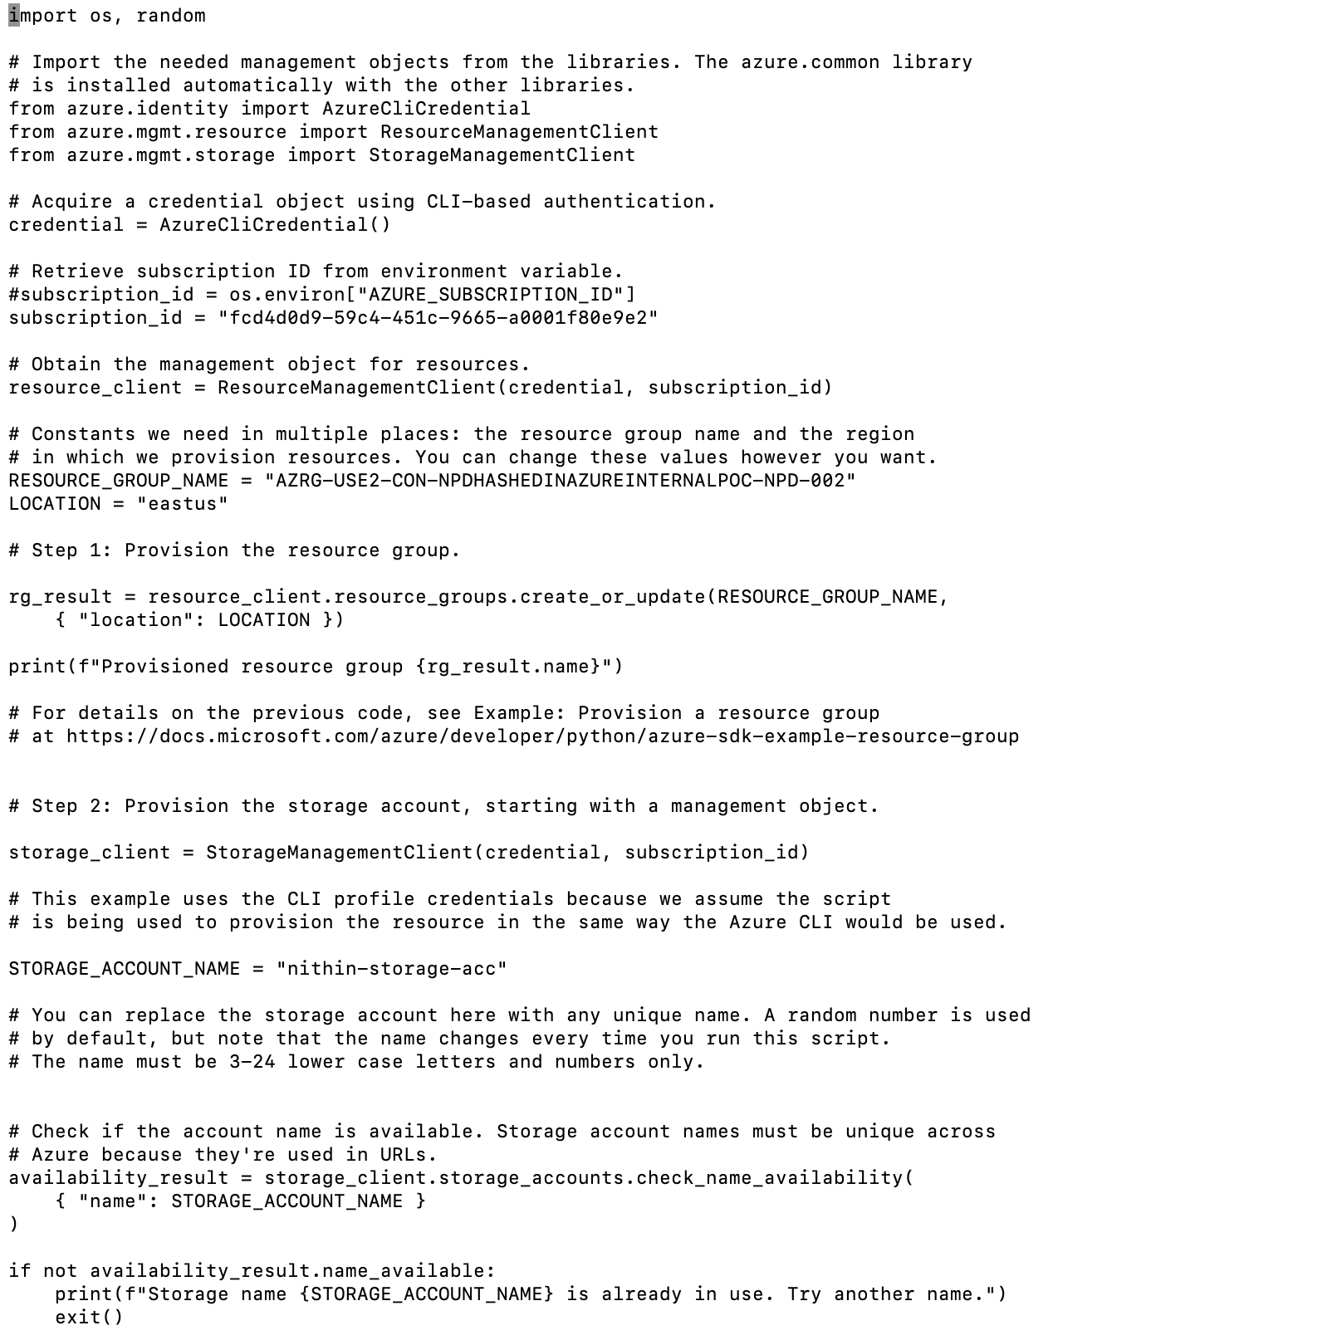

Install all the packages using pip and now we are trying to provision resource group with appropriate resource group names and create a storage account with nithin-storage-acc to manage the objects.

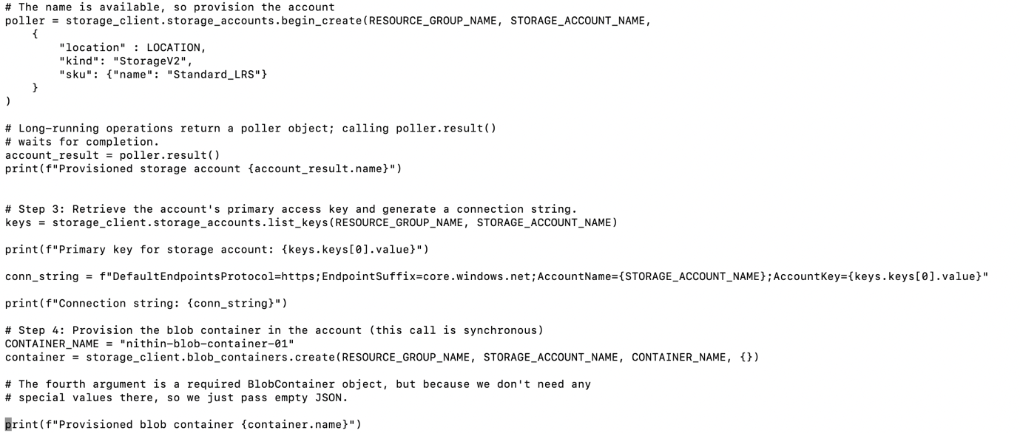

Now we are configuring with a particular location and create a container to store blob file

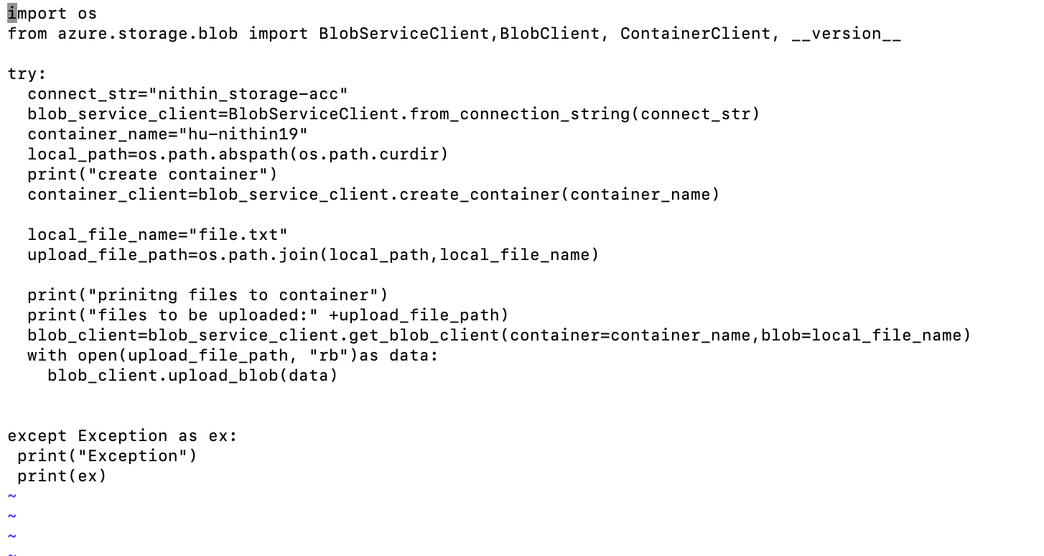

This is used to upload files inside container name hu-nithin19 accepts 2 parameters like which container and which file name based on that it uploads files.

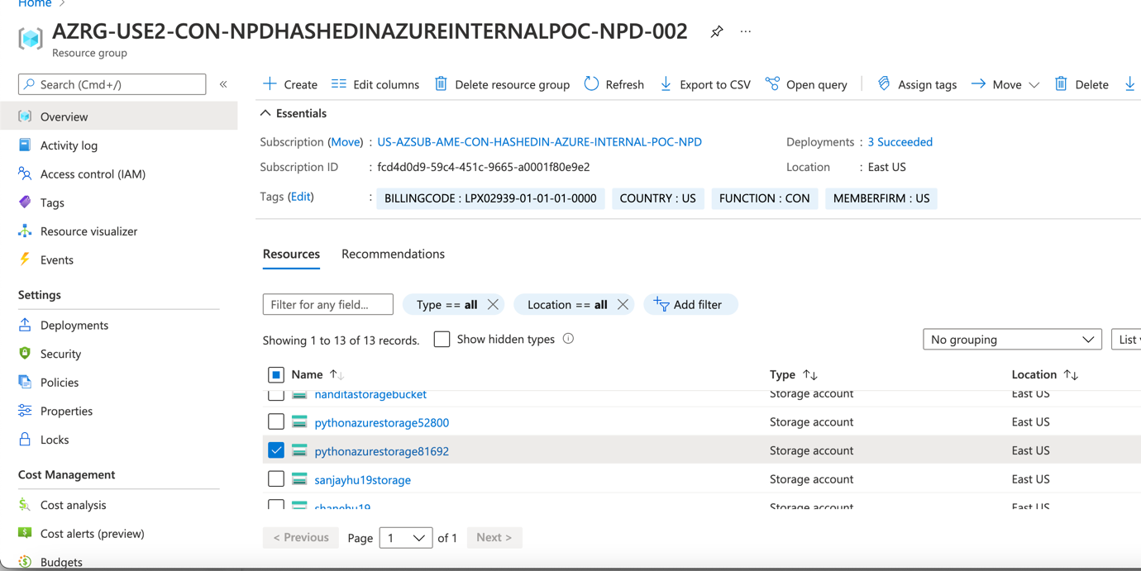

Inside resource named AZRG-USE2_CON..002 and storage account name

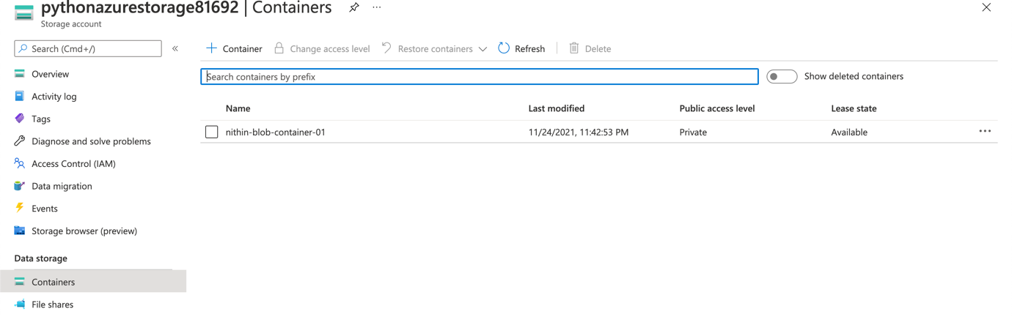

I have a container named nithin-blob-container-01

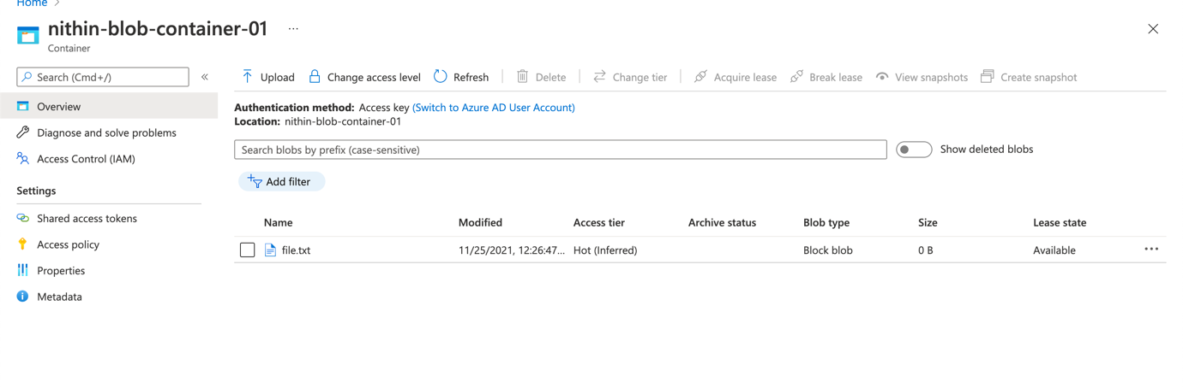

Inside that container I have uploaded file.txt

2.)Write a script to list-down all the files in the container

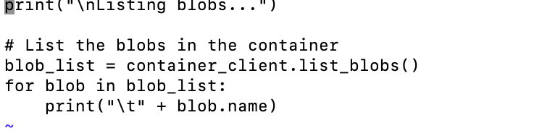

This is used to list blobs of files accordiningly

3.) Write a script to delete all the files and the container and the storage account that you have created

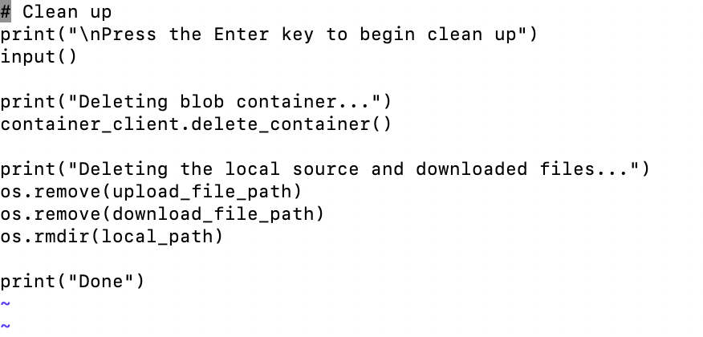

To delete a file we ashould remove uploaded file and rmdir also

4.) Write a script to provision virtual network, subnet, Network Interface client (NIC), Virtual machine in the given location, and resource group.

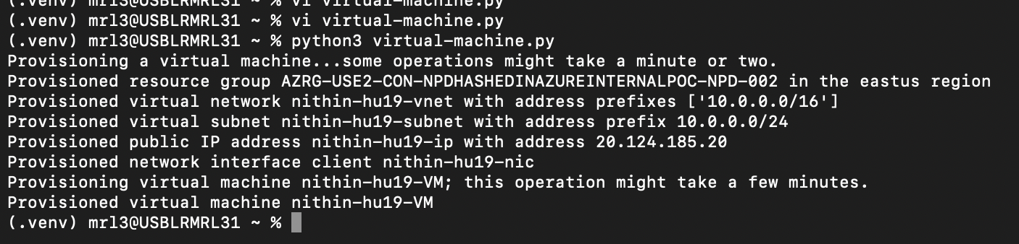

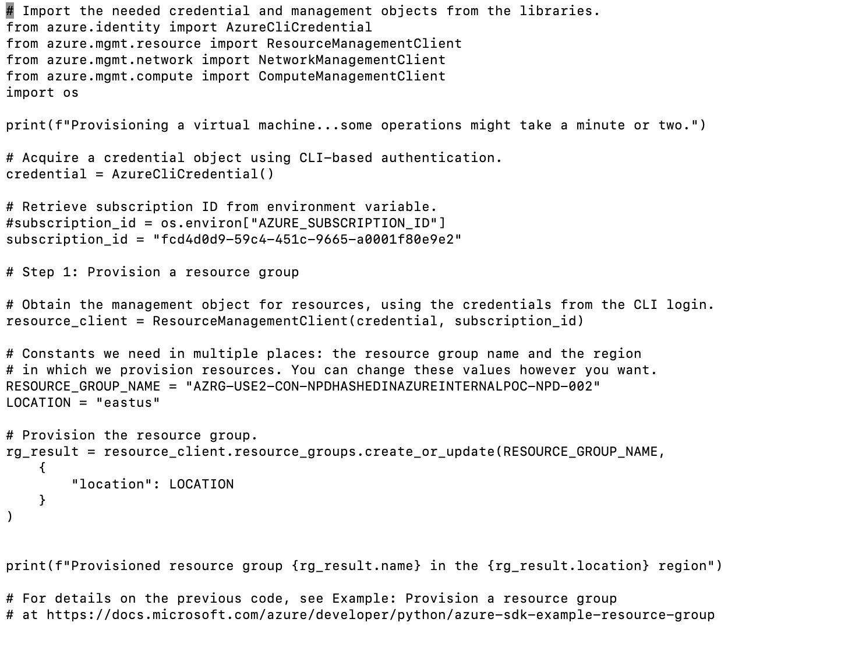

Step1 used to provision resource group

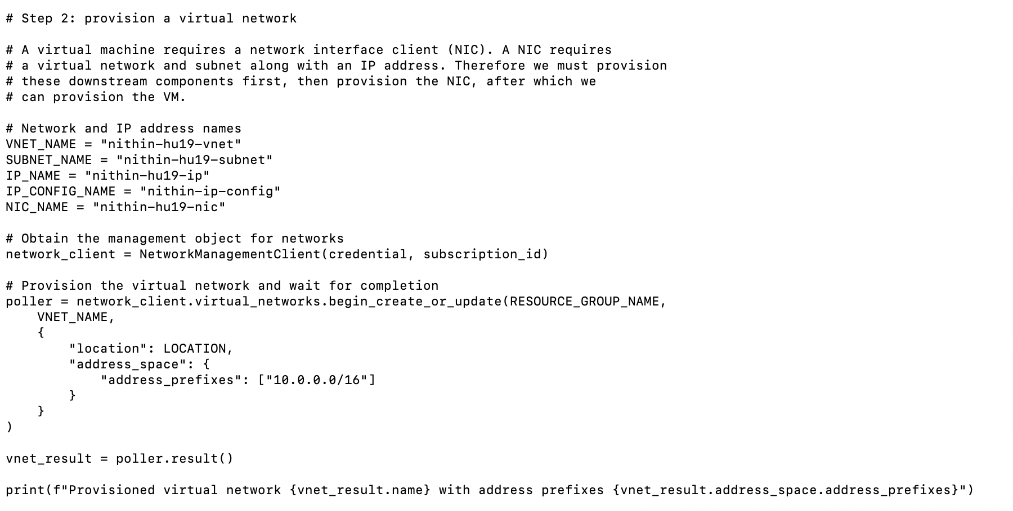

Step 2 provision virtual network with name nithin-hu19-vnet and subnet name as nithin-hu19-subnet etc…

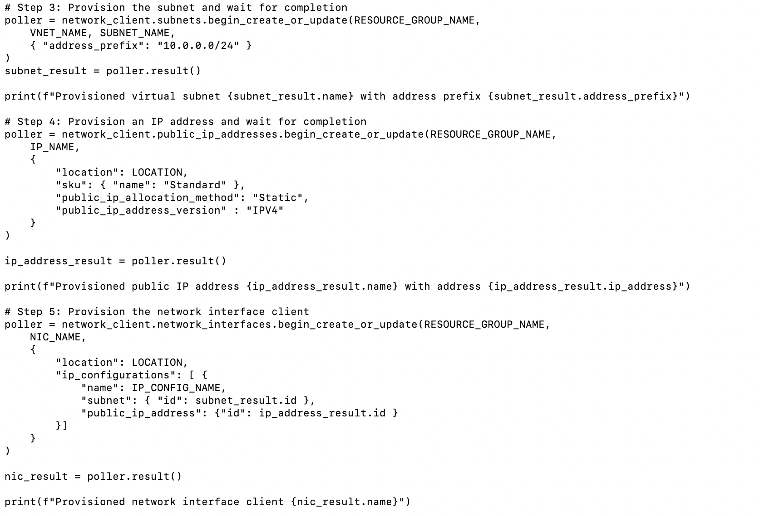

Step3 is used to provision subnet and wait for completion of establishing inside vNet with appropriate subnet

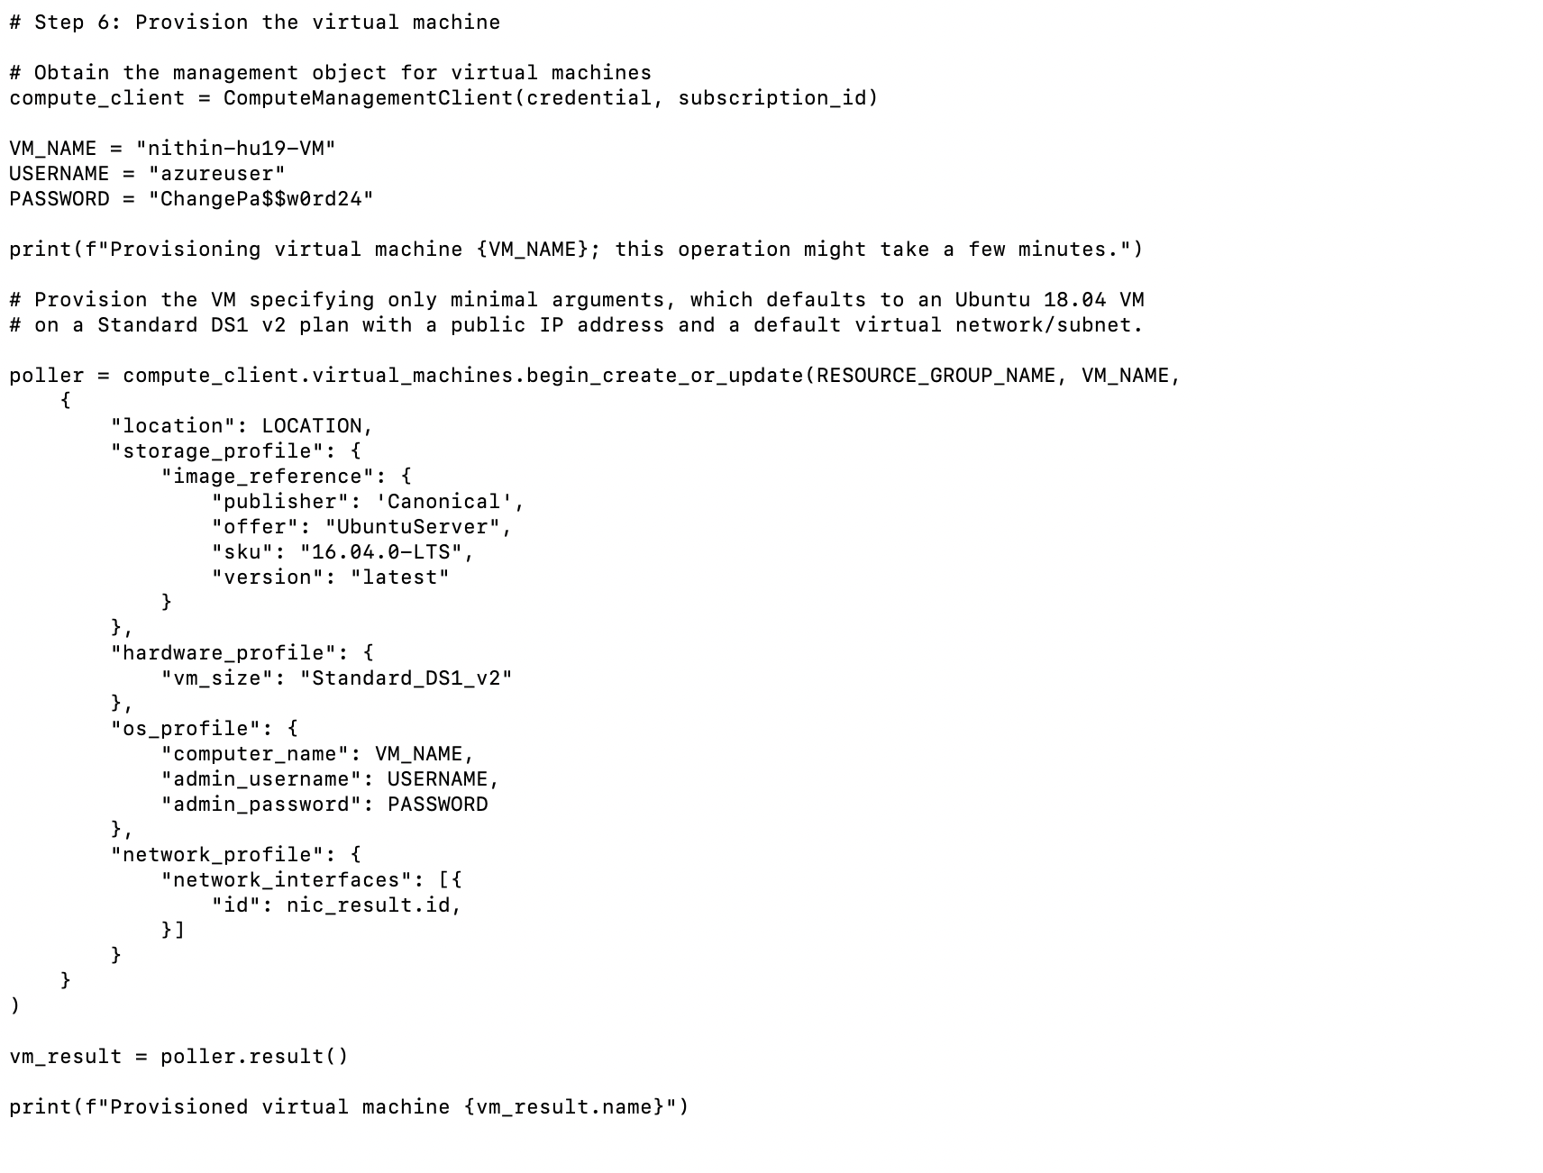

This step is used to create a new Vm which says wheather it is apublic or private according to rerquirement

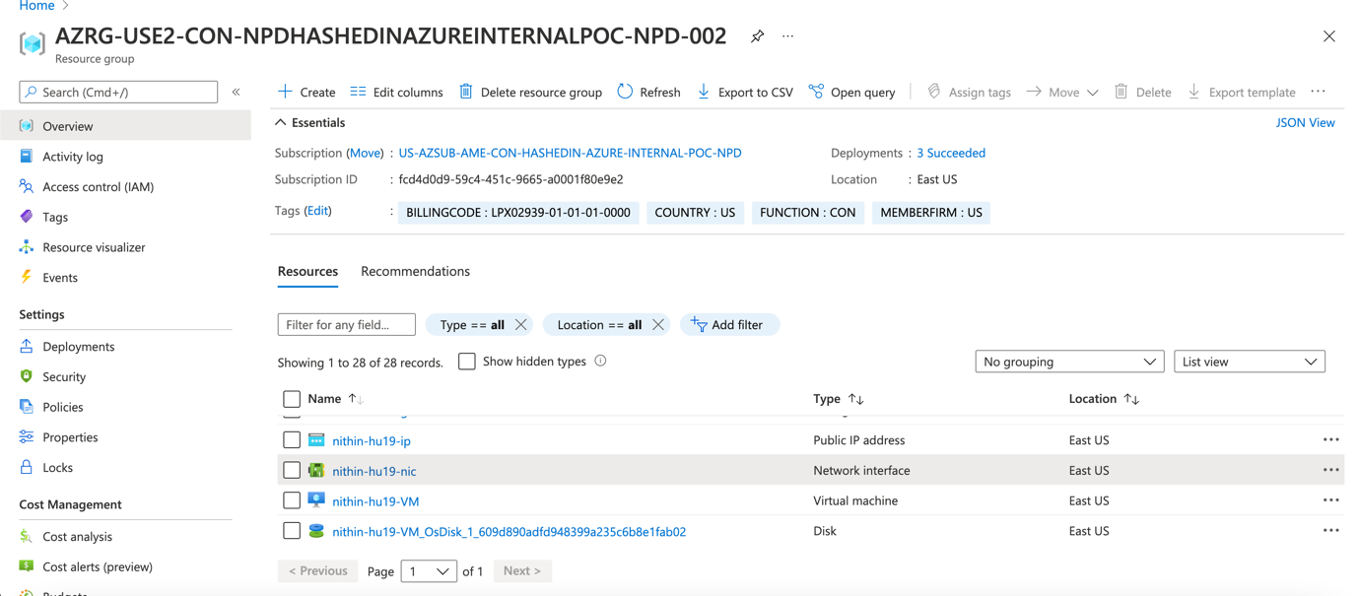

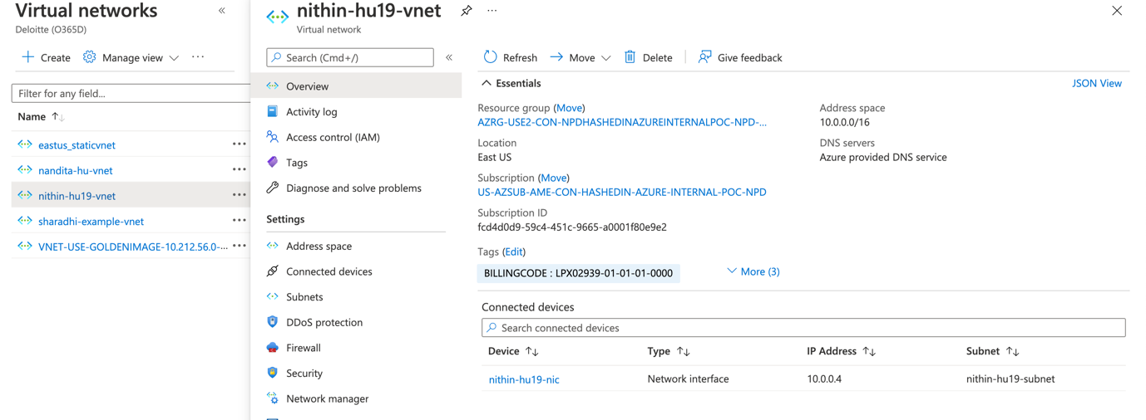

Inside vnet we have network interface

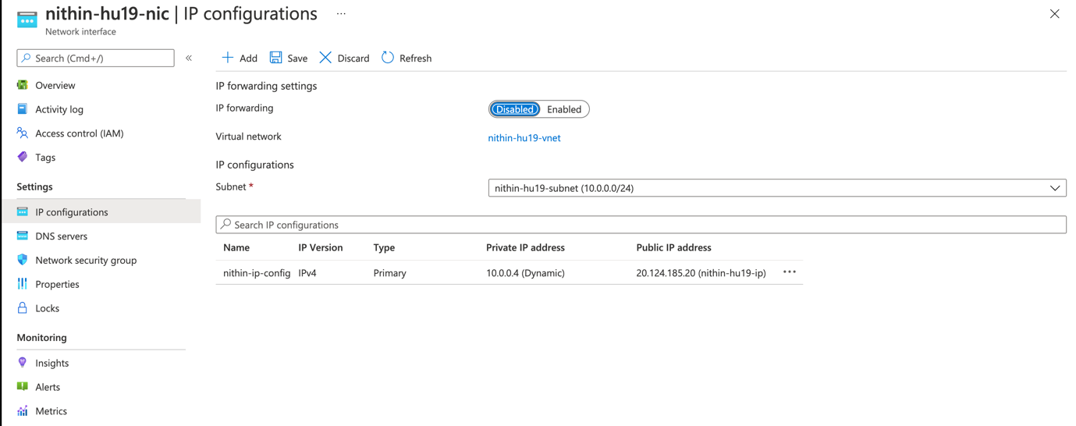

Which shows that ipconfig by configuring their private and public IP

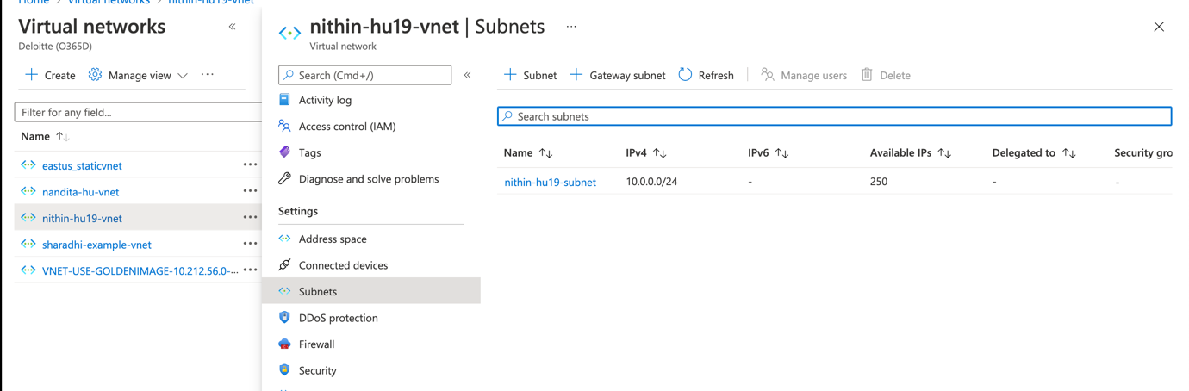

Inside vNet we have subnet which is IPv4

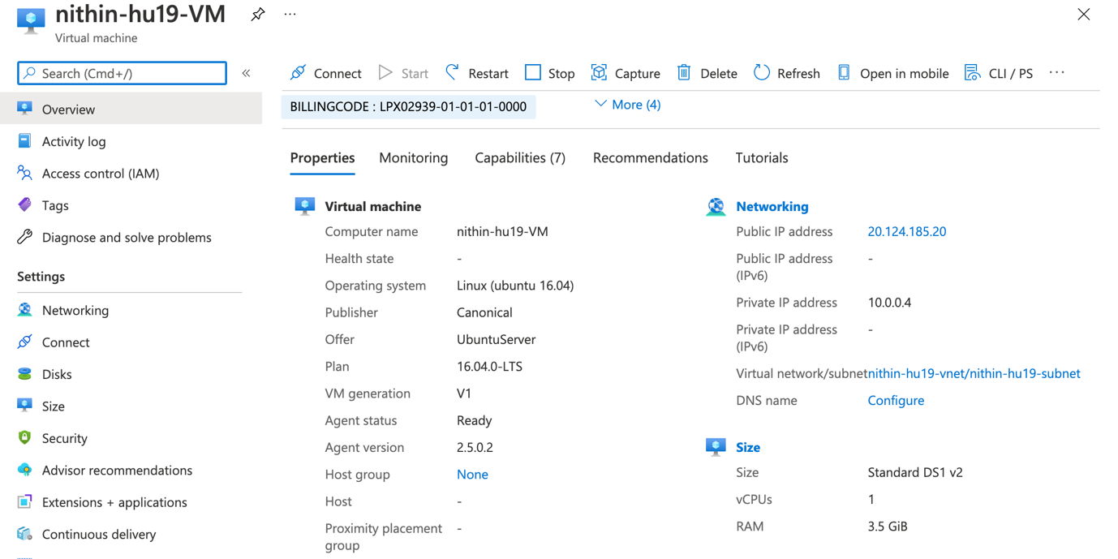

This Vm used to show it is under vnet nithin-hu19-vnet and subnet nithin-hu19-subnet

5.) Write a script to list all the Virtual Machines in a resource group

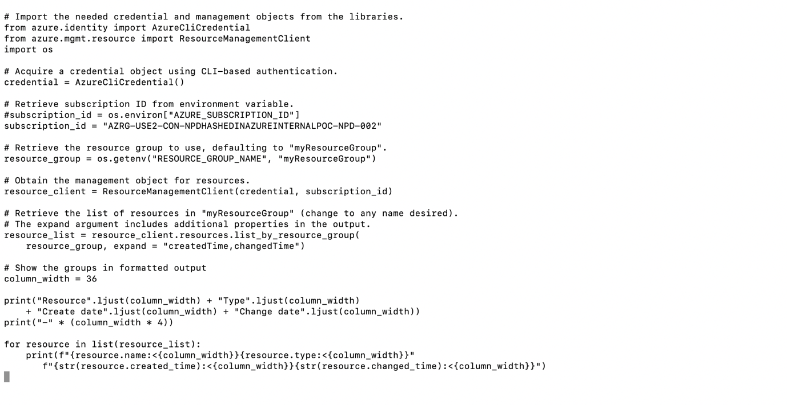

6.) Write a script to create an app service plan. (SKU – B1) (1)

7.) Write a script to create a Linux and python based webapp in the app service plan that you created. (1)

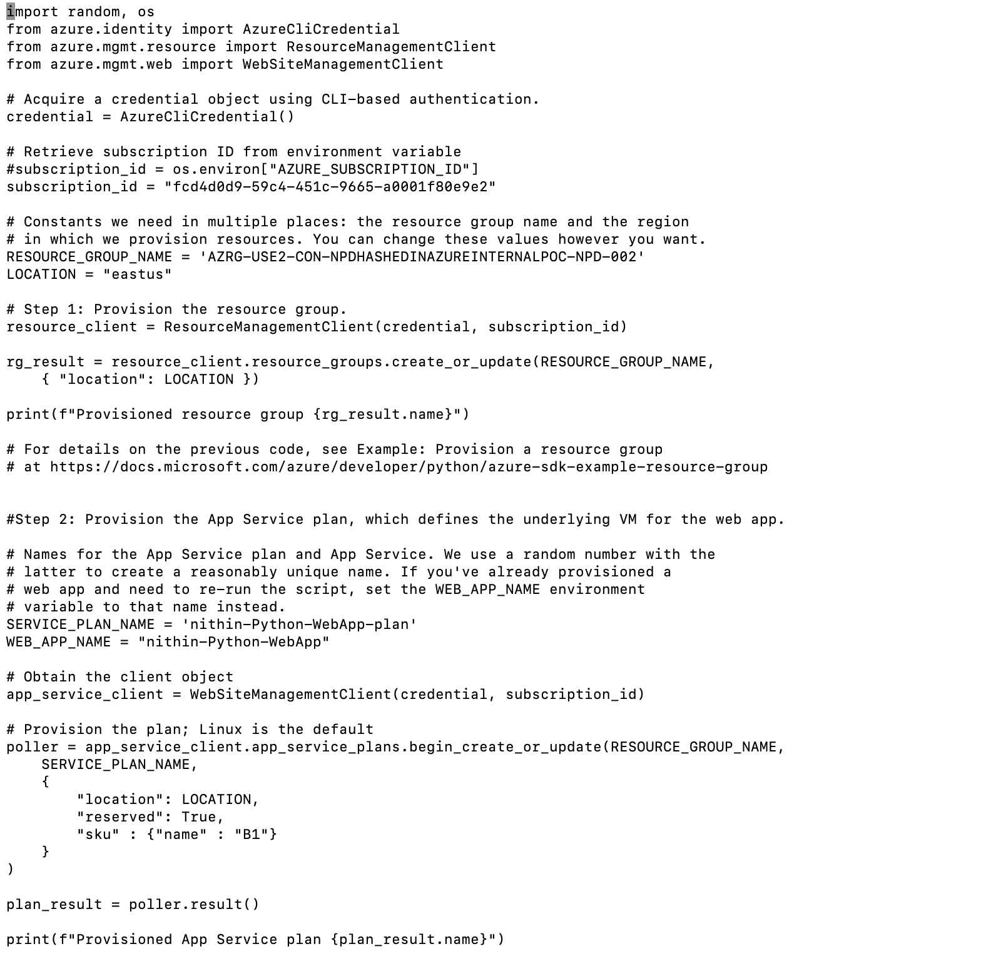

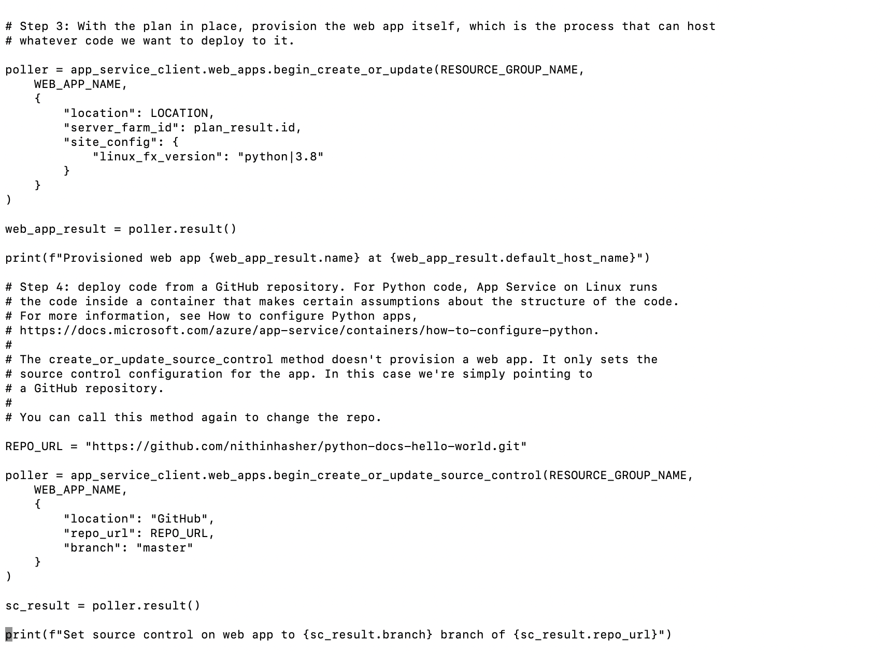

8.) Fork this repository - https://github.com/Azure-Samples/python-docs-hello-world . Write a script to deploy this code directly from git to the webapp that you created.

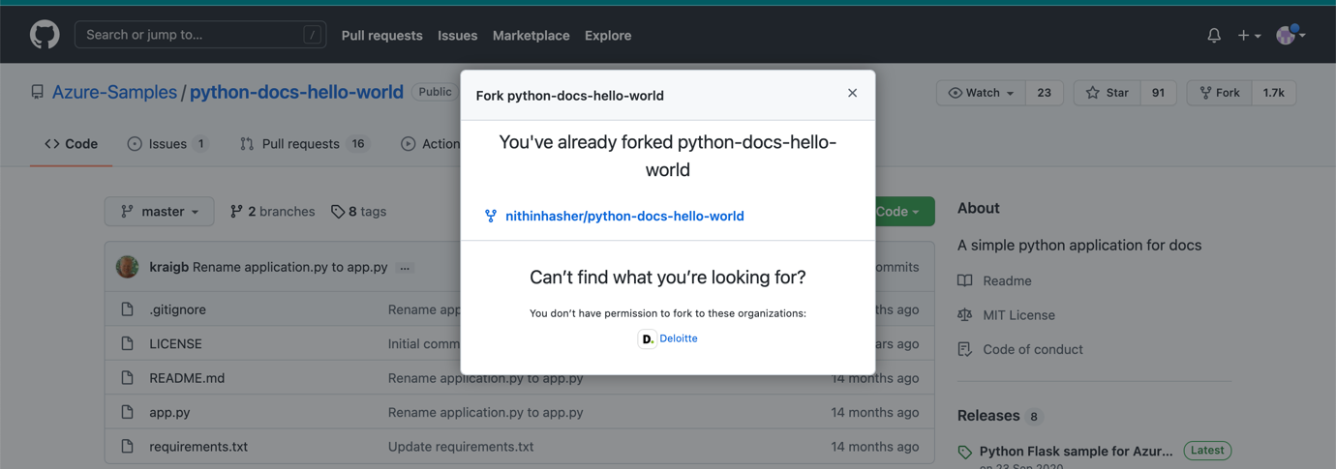

Go to github repo and fork it then it ll fork to your github and creates a file inside your repo

Then we should go to our github repo and copy paste it to the REPO_URL of the app script

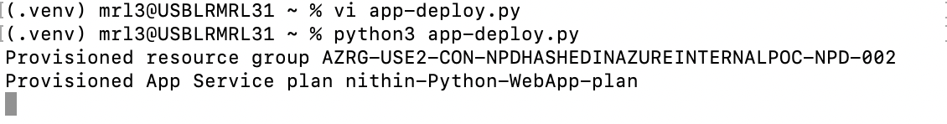

Try to run the app-deploy.py app and see everything is logging with a correct message and it is provisioning App service plan as well



This command is used to deploy your application webApp on particular resource group

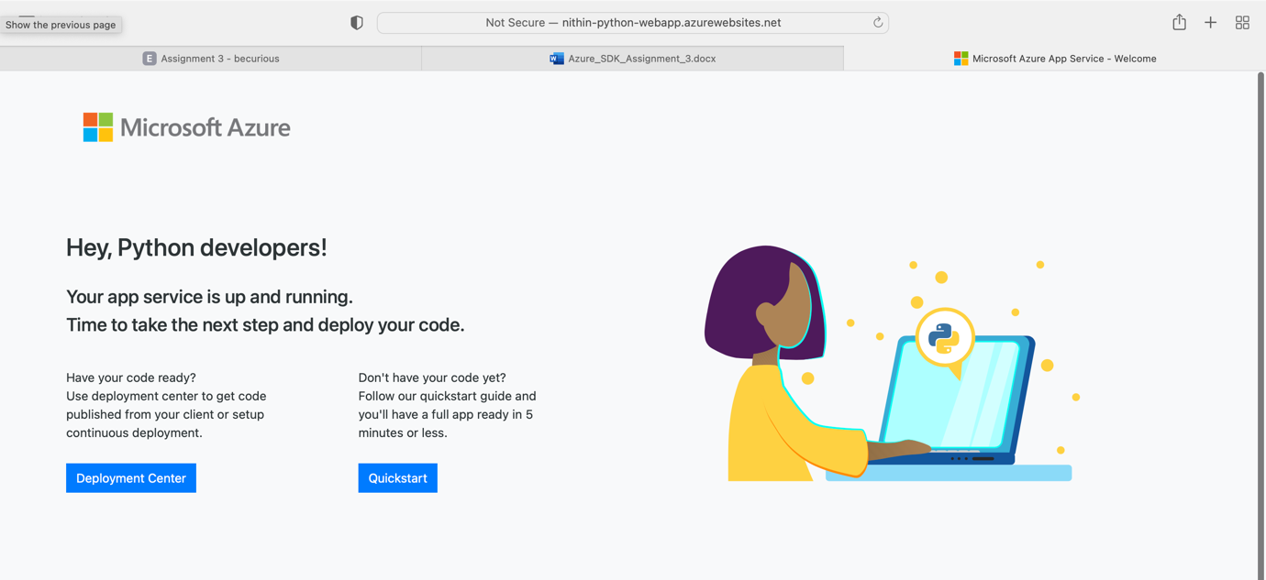

Finally you can see your output in this way.